Library logo 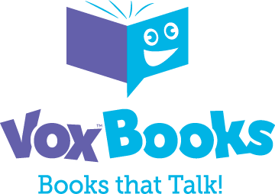

FOR IMMEDIATE RELEASE

New Entertaining and Educational Offering for Young Readers
Library name now offers VOX™ Books to all its patrons

CITY, State – Month Day, Year – Parents and other caregivers are always looking for ways to make learning fun and engaging for the children in their care. Thanks to a new offering from Library name, they won’t need to look far!

VOX™ Books are the world’s first all-in-one read-along: readers can listen to the book while they read through it. VOX Books don’t require CDs, tapes, batteries, devices, or internet access; just press a button and you’re listening and reading! VOX Books can also be used with or without headphones, making them perfect for both solo and group enjoyment.

Library area residents can borrow these engaging VOX Books for free. All they need is a library card!

[Add a quote from a Library staff member or patron about their or their children’s experience with VOX Books here]
VOX Books have won awards from parents’ groups, including the 2021 National Parenting Product Award in their Best Books for Kids and Families category, and a 2021 Mom’s Choice Award. A recent review in School Library Journal noted that “Narrators are lively and will keep readers engaged. Educators can use VOX Books to help early or struggling readers learn to pronounce words, hold a book, and turn pages, and practice tracking text from left to right. This is a valuable tool not only for libraries but also for teachers to use in the classroom and for parents to use at home.”
Visit Library website URL for more information and to reserve a VOX Book!

About Library name
Add boilerplate description

About Library Ideas
Library Ideas is a global media company with an unwavering focus and desire to provide innovative digital solutions and ideas to libraries around the world. We proudly distribute e-content, design and build our own innovative products, and directly handle customer service to ensure optimal satisfaction. Established in 2008, by several publishing executives, Library Ideas® has over 5,000 customers in over 20 countries around the world. In 2011-12, Library Ideas® was named to the EContent 100 as one of the companies that matters most in the delivery of e-content. The company has offices in Fairfax, Virginia and Chattanooga, Tennessee.
Contact:
Library contact name
Library name
Phone number
Email address

Email template for sending out press releases

Dear (name),

My name is (your name). I’m the (job title) at (library name).

We wanted to pass along the press release below and check whether (news outlet name) is interested in covering it? We’d love to alert your audience to this exciting new offering. We are happy to provide an interview with one of our library representatives if you’re interested.

Please let me know!

Thanks,
(Your name and sig file)

[Insert press release here]

